Digital Program – Digital Client Onboarding
Project Statement

Contents
1.0 Purpose 3
2.0 Project Overview and Scope 3
3.0 Scope 3
4.0 Benefits and Costs 3
5.0 Key Success Factors 5
6.0 Project Completion Criteria 5
7.0 Constraints and Dependencies 6
8.0 Project Approach and Timelines 6
9.0 Stakeholders 7
10.0 Risks Summary 7
11.0 Project Governance 7
12.0 Approvals 8

Purpose
The purpose of this project statement is to define project specific information not captured in enough details in the program management deliverables. Similarly to a project charter, this project statement formalizes the existence of the Project and provides the Project Manager with the authority to start work activities.

Project Overview and Scope
Background
The Digital Program was approved by PSC and kicked off in December 2019.
The Digital Program has the following projects identified:
- Digital Client Onboarding
- Digital Online Banking
This project statement will focus on the Digital Client Onboarding.
For additional information, see the Digital Program Charter.

Scope
In-Scope
The scope of the Digital Client Onboarding project includes:
- Implementation of the Motive Client Onboarding processes;
- Implementation of the Personal Client Onboarding processes including in-branch implementation;
- Implementation of the Small Business Client Onboarding processes;
- Implementation of Small Business Lending;
- Implementation of client and operational DCO support processes;
- Integration of the Mulesoft Platform for client onboarding; Enhancement of T24 web services required to support client onboarding; and
- Integration with third party integrations such as thirdstream, Flinks, etc.

Out-of-Scope
The following items are out-of-scope for this project:
- CWB Partner Companies use of these solutions (outside Motive and CWB);
- Automation of processes outside of the digital tools

Benefits and Costs
Delivering the scope of the project is expected to deliver tangible and intangible benefits. These will be tracked centrally and the results will be reported to PSC after the implementation. More information is available in the PMO Reportable Benefit Guideline.
Benefits
The benefits for the Digital Client Onboarding project are:

Benefit Summary | Tangible / Intangible | Key Organization Goals | Target Metric to be Achieved | Report Date on Target Metric | Benefit Owner
Personal clients are provided with a more efficient way to onboard offering personal clients a better client experience. | Intangible | Improves client experience | Improve the time for clients to onboard from more than 45 minutes to less than 10 minutes.  Measure the current time it takes to open an account (see CAPE research) vs the time it takes after implementation of DCO. | Immediately after Personal DCO implementation. | Christina Mullin
Expand CWB’s footprint to new geographic areas. | Intangible | Diversifies our presence geographically | Acquire new clients in geographic areas where we currently do not have.  Report of current geographic client data compared to new data. | 12 months after DCO Program stream implementation. | Christina Mullin
Reduce staff time in Motive for responding to manual request of client onboarding that will be now be offered online | Intangible | Makes CWB more efficient and/or more productive | It is estimated to reduce the Motive staff time as clients will now have the capability to open accounts online themselves.  Measure the current time it takes Motive staff to open an account vs the time it takes after implementation of DCO. | 6 months after Full Motive DCO. | Christina Mullin
Motive and CWB Personal - Create capacity to re-focus people resources to other value added activities | Intangible |  | Automate the client onboarding process currently being completed manually (supported by time/motion studies) | 6 months after DCO Program stream implementation. | Christina Mullin
Reduce staff time in CWB branches for onboarding Personal clients | Intangible | Makes CWB more efficient and/or more productive | Measure the number of accounts opened through the DCO that a staff member did not need to open on their behalf. | 6 months after Personal DCO implementation. | Christina Mullin
Reduce staff time in CWB branches for onboarding Small Business clients. | Intangible | Makes CWB more efficient and/or more productive | Measure the number of accounts opened through the DCO that a staff member did not need to open on their behalf. | 12 months after Small Business DCO implementation. | Christina Mullin
Improving team members satisfaction for Personal DCO | Intangible | Improves the employee experience | Improve staff satisfaction to achieve an overall rating of 80% for Personal DCO onboarding.  Survey after Personal DCO implementation that shows staff ratings of “Meets” or greater for the Personal onboarding process. | 6 months after Personal DCO implementation. | Christina Mullin
Improving team members satisfaction for Small Business DCO | Intangible | Improves the employee experience | Improve staff satisfaction to achieve an overall rating of 80% for Small Business DCO onboarding.  Survey after Small Business DCO implementation that shows staff ratings of “Meets” or greater for the Small Business onboarding process. | 6 months after Small Business DCO implementation. | Christina Mullin

Financial Cost Benefit Analysis
The following is a summary of the Program cost benefit analysis. Full details are available in the PMO Cost Benefit Analysis spreadsheet on the project SharePoint site. The financials will be managed at the program level.
Category | Capital or NIE | Estimated Budget
Software | Capital | $2,930,875
Labour | Capital | $2,647,894
Other (Partner Travel) | Capital | $80,000
Contingency | Capital | $606,087
TOTAL PROGRAM CAPITAL |  | $6,264,856
Software | NIE | $723,275
Other | NIE | $1,000,000
Labour | NIE | $108,900
TOTAL PROGRAM NIE |  | $1,832,175
TOTAL PROGRAM BUDGET |  | $8,097,031

Note: The budget is currently with Finance under review to confirm the NIE and Capital allocations. Once complete an out of budget request will be submitted to address the delta.

Key Success Factors
The project will follow the same key success factors defined for the program within the Program Charter.

The following factors must be in place in order for the benefits listed above to be enabled:

- Adherence to the PMO Guiding Principles

Project Completion Criteria
This project will be considered complete when the key deliverables have been completed, the technical changes have been deployed to production, and the transition to operations has been completed. The project will provide go live support for 60 days after the deployment.

Constraints and Dependencies
The following are the constraints for this project.
- There are time constraints due to the partners fixed price contract.

The following are the dependencies for this project related to other projects.
- Digital Banking Project for Small Business and Personal as it may leverage the client onboarding solution for opening accounts;
- CWB Mulesoft and Infrastructure Implementation Project in order to leverage the integration solution for T24;
- AML Financial Crimes Project in order to leverage any AML processes for automation into the account opening process;
- Identity and Access Management for client access and authentication through OKTA;
- New CDIC Compliance Requirements - CDIC New date capture requirements during Account Opening (primarily for Trust Accounts);
- Forms Enhancement Phase 1 - Branch impacts due to Forms Project that could overlap Digital Program Go Live Dates, OCM concern for staff;
- Private Cloud for T24 – The T24 environments will be moved from on-premise to the cloud. Will need to coordinate any changes to the digital T24 environments;
- IS Application Services - Equifax upgrade project – Will need to test the upgrade to ensure no impact to the Digital APIs for Equifax.

Project Approach and Timelines
Approach
This project will be executed following a blend of the agile and waterfall development methodologies. The delivery approach will follow the PMO’s PDLC framework but will be rationalized to leverage established Digital Program oversight and delivery capabilities.

Key Milestones/Deliverables and Timeline
The following are the key milestones/deliverables and estimated timelines for this project. Timelines will be further refined during the planning phase.

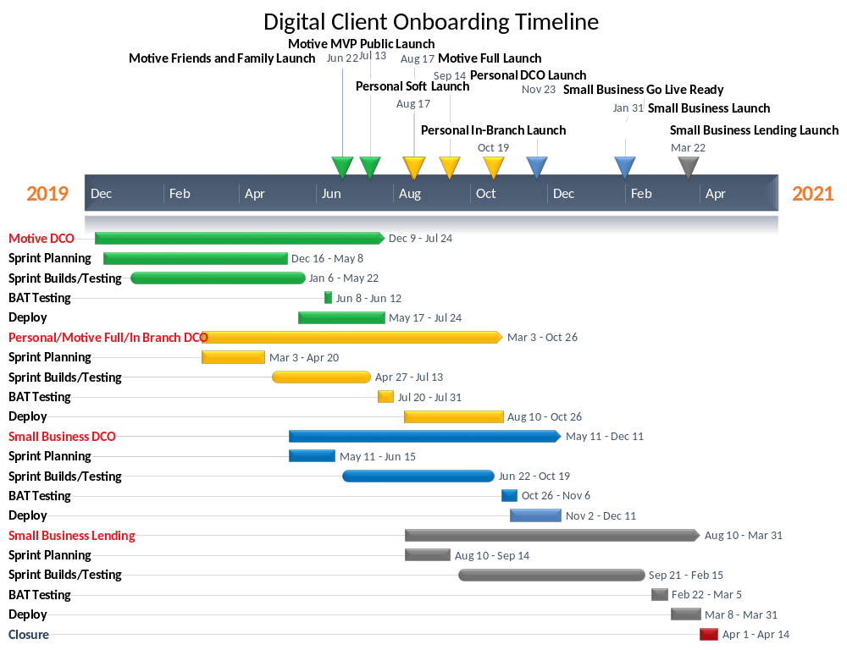

The deliverables and dates outlined above have been drafted based on an understanding of the project scope, required tasks, development timeframes and resource availability at this point in time. As project planning activities are completed and time elapses the dates may be modified. The Small Business DCO will be launched with the Small Business Banking project.

Stakeholders
The Stakeholders have been identified in the Digital Program Charter.
Further details about the stakeholders of this project can be found in the Digital Program Stakeholder Register.

Risks Summary
The project risks will be documented and managed in the Digital Program Risk Log.

Project Governance
Project Structure
The project will follow the governance structure defined within the Digital Program Charter.
Project Management Plan
This Project will follow the project management processes established by the PMO as defined in the Digital Program Management Plan.
Project Communications
The project will follow the communications defined within the Digital Program Charter.

Approvals
Authorization to Proceed:
Sign-off is required from the following people to proceed with this project based on the objectives, scope and responsibilities documented in this Project Statement:

Christina Mullin, VP Digital and Alternative Channels  Business Program Owner |  | 07/28/2020 | Signature: | or | ☒ Digital Approval  (Click the box to select)
Jason Bond, Sr AVP Application Services  Technical Program Owner  Gerry Weber for Jason |  | 07/27/2020 | Signature: | or | ☐ Digital Approval  (Click the box to select)  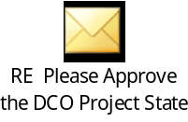
Jogi Nijjar, Program Manager, PMO |  | 06/29/2020 | Signature: | or | ☒ Digital Approval  (Click the box to select)
Kate Jekabson, Project Manager, PMO |  | 06/11/2020 | Signature: | or | ☒ Digital Approval  (Click the box to select)
Bruno Freitas, AVP, Program Management |  | 06/12/2020 | Signature: | or | ☒ Digital Approval  (Click the box to select)
Barb Keryliuk, Sr. Manager, PMO |  | 06/11/2020 | Signature: | or | ☒ Digital Approval  (Click the box to select)

